PROFITABLE WEBSITE PHASE 1 ESTIMATE

In order for UNLIMITED WEB DESIGNS to provide a clear phase 1 estimate, we need to know the details of the web site you have in mind. This form will guide you in providing the information we need and will serve as a Request For Proposal on which we will base our estimate. Please understand that as the process begins ideas emerge, these ideas will be filtered through forms to your project leader and compared to your original estimate. If these changes or ideas do not appear on the original phase 1 proposal we have a system that will send out a phase 2 addition. The client will receive a website project change order for their approval*.

Please type your answer after each question. The more complete your idea the more accurate the quote and the stronger and faster the development of your website. When you’re done, save the document and send it as an attachment to emilio@unlimitedwebdesigns.com. We’ll go over your phase 1 paper work and provide you with a proposal and estimate.

At UNLIMITED WEB DESIGNS we realize that this will require some time and effort, but it’s crucial to the estimating process. Thank you!

Contact Information: Highlight in Yellow what will NOT appear on site, this portion is required for our files.

OUTCOME
What is the outcome financially and what is the functionality.

SITE TYPE?
E-commerce, Informative, Organizational, Image, Social Networking.

CONTACT INFORMATION
Your name and title:

Name of business or organization:

Your email address:

Best phone numbers for reaching you:

COMPANY INFORMATION
Company name:

Please describe your company or organization in a few sentences:

Other than you, who else will be involved in guiding this project to completion?

EXISTING WEB SITE
If you have an existing web site, what is the URL? (Web Address, e.g. www.company.com)?

What more would you want from your website?

What would you like to change, add or subtract?

DOMAIN NAMES AND HOSTING
Do you have a domain name or names registered? What are they?

Like most web developers, we would always prefer to make hosting arrangements for sites we produce. Will that work for you, or do you have an existing commitment to a particular web host? If so, why?

If your site is currently being hosted please provide hosting company, login and password information, FTP login and password information.

PURPOSE AND GOALS FOR WEB SITE
What are the purposes of this web site? (Web Address, e.g. www.company.com)?

Who is your target audience?

What will they be able to learn or do there?

List the business objectives for your website in order of importance. e. g. improve sales, increase customer satisfaction, reduce time spent searching for information etc.

- ___________________________________________________________________________________
- ___________________________________________________________________________________
- ___________________________________________________________________________________
- ___________________________________________________________________________________
- ___________________________________________________________________________________
- ___________________________________________________________________________________

TEXT AND GRAPHIC CONTENT
Please make a list of planned site pages and/or groups of pages.

Do you have a company logo you’re satisfied with and want to use? This must be provided in 300 dpi Adobe illustrator format. If you do not have these criteria we will estimate creating it for you.

Please describe any other graphic images (photos, illustrations, etc) you already possess which would be included on the web site? What is the approximate total number of graphics? Here you can simply estimate the number of pages and multiply these pages by the number of graphics you want to display on each page. If you do not currently own your graphics we have two options please choose either;

We acquire
- By allowing us to choose the graphic you understand that we will be billing hourly for this service, we will then send you the graphics choices and you will approve or disapprove and we will continue to create choices, this is an hourly process and dynamic so your bill will be reflective of this process. Your estimate will include our best guess based on your criteria. If we go over this hourly you will be sent a website project change order with additional cost estimate for approval and signature.

You acquire
- When you integrate yourself into the process we will guide you to stock graphic sources, help you open an account and create a light box. You will then be able to sort through thousands of filtered and available graphics, load them into your light box for us to see. We will then go into the light box and purchase through your account the choices that you have selected. This is the best method as it saves time money and keeps you in the creative process. YOU also must own your own artwork for legal reasons so you are now covered. This is included in the estimate.

DESIGN STYLE AND BRANDING
Is there a specific design style you wish to incorporate into the web site? If so, please describe it as well as you can. When we are ready to move forward we will integrate your answers from phase 1 into a comprehensive work flow for your profitable website form. Within this form you will find best practices, psychology color choices and recommendations as well as internet theory.

Please list the websites of competitors and organizations in a related field. What works? What doesn’t?
What we are looking for specifically is what you are looking for and will expect. By showing us the websites you feel you like or will be competing against we will have a better understanding of your project and be better able to give you a complete estimate.

- http://_______________________________________________________________________________________
Comments:___________________________________________________________________________________

- http://_______________________________________________________________________________________
Comments:___________________________________________________________________________________

- http://_______________________________________________________________________________________
Comments:___________________________________________________________________________________

List websites you like the visual design of and explain why.
Here we are trying to determine your style. Simple is not always inexpensive so by looking at what you like from a style sense we will again have a clearer understanding of your outcome and vision.

- http://_______________________________________________________________________________________
Why?________________________________________________________________________________________

- http://_______________________________________________________________________________________
Why?________________________________________________________________________________________

INTERACTIVITY, E-COMMERCE
Will the site need a form allowing site visitors to contact you for information?

Will the site be selling anything? If so, please describe the type and number of products, and tell us as much as you can about how you’d like your shopping cart and checkout process to function.

Please tell us about any other interactive features you would like to incorporate.

Will you be looking to develop a client list?

What will you want to do with emails that are collected? Remember that the strength of your site is based on the strength of your data base. By working this into the front of your design you will be able to accurately gauge what clients are searching for and WHO your clients really are. This is a programming feature and is not automatically included in your site so it must be estimated in the cost. If you would like we can estimate this as a separate component that can be added to the site at a later date. Please advise how you would like this estimated and if you will want the feature in the future we will build a back end to accommodate later.

ANIMATION/AUDIO/VIDEO
Do you plan to include animation, audio or video on your site? If so, please describe it. How will it add value? This is a program intensive aspect of site development so please make sure that it is something that you need.

FUTURE MAINTENANCE OPTIONS
We do not recommend that you work directly on your site using any other web design software. We will not ever guarantee yours when this occurs.

However, we can provide what is known as a Content Management System, allowing you to add to and update much of the content of your site using your web browser. This adds significantly to the cost of producing your site, but can be ideal for some organizations that have dynamic changing content weekly or more. If you believe that your content will need monthly updates or less we have a retainer package available that is very reasonable and assures the integrity of your site. Are you interested in a Content Management System?

TIME FRAME
What is your time frame for producing and launching the site?

SEARCH ENGINE PLACEMENT
Are good rankings on search engines important for this web site? If so, please list the most important key words or key phrases which would be used to find you. The search engine packages are sold separately and will include a monthly charge adjusted to the level of package chosen. What will be included will be the set up and organization of SEO, this will require additional programming but we do not build sites without including this.

OTHER CONSIDERATIONS
Please tell us anything else we need to know about the planned web site.

SITE STRUCTURE

BRANDING

Do you want the same header from the home page to be on all inner pages? Most pages use this technique for Branding, if not specify which links / sections will be different?

- How many links / sections will you want on the site?

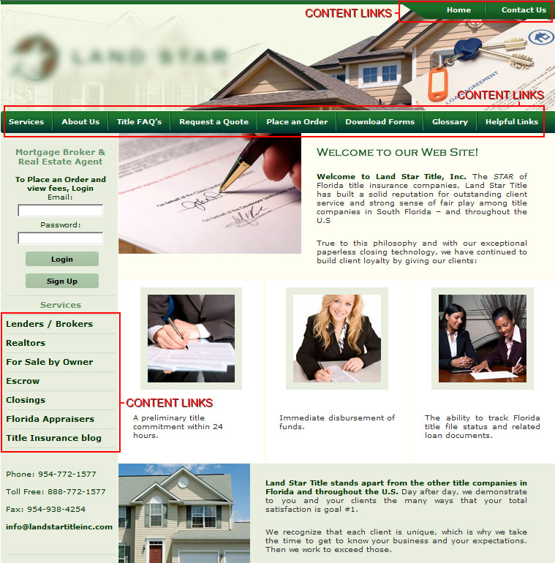

- Please describe any other graphic images (photos, illustrations, etc) you already possess which would be included on the links / sections (inner pages). What is the approximate total number of graphics?

- Is there a specific design style you wish to incorporate into links / sections (inner pages)? If so, please describe it as well as you can.

- Which of the links / sections (inner pages) have CMS (Contact Management System)

